**ARRAYS AND**

**STRUCTURES**

**LAB # 13**



**Spring 2019**

**CSE102L Computer Programming Lab**

Submitted by: **SHAH RAZA**

Registration No. : **18PWCSE1658**

Class Section: **B**

“On my honor, as student of University of Engineering and Technology, I have neither given nor received unauthorized assistance on this academic work.”

Student Signature: ______________

Submitted to:

**Engr. Madiha Sher**

June 21, 2019

Department of Computer Systems Engineering

University of Engineering and Technology, Peshawar

## Objectives:

To practice arrays and structures

**TASK #1**

Write a Store the temperature of last 10 days of 3 cities in the database and display for how many days the temperature was below 30 degree and how many days it was above 30 in each city. Find the average temperature of each city and display which city is the warmest.

**Code:**

#include <iostream>

using namespace std;

void input(int A[3][10]) //Definition of input function

{

for(int r=0;r<3;r++) //Loop for rows

{

cout<<"Temperature of city "<<r+1<<endl;

for(int c=0;c<10;c++) //Loop for columns

{

cin>>A[r][c]; //Array Entry

}

}

}

void AB(int A[3][10]) //Definition of AB function

{

for(int r=0;r<3;r++) //Loop for rows

{

int below=0,above=0; //Variable Declaration

for(int c=0;c<10;c++) //Loop for columns

{

if(A[r][c]>30)

above++; //Increment above

else if(A[r][c]<30)

below++; //Increment below

}

cout<<"City "<<r+1<<" : Temperature below 30: "<<below<<" Day(s). ";

cout<<"Temperature above 30: "<<above<<" Day(s).\n";

}

}

void Avgtemp(int A[3][10]) //Definition of Avgtemp Function

{

int sum[3][1]={0}; //Array declaration

for(int r=0;r<3;r++) //Loop for rows

{

for(int c=0;c<10;c++) //Loop for columns

{

sum[r][0]+=A[r][c];

}

cout<<"Average temperature of city "<<r+1<<" : "<<sum[r][0]/10.0<<endl;

}

if(sum[0][0]>sum[1][0]&&sum[0][0]>sum[2][0])

cout<<"City 1 is the Warmest";

else if(sum[1][0]>sum[0][0]&&sum[1][0]>sum[2][0])

cout<<"City 2 is the Warmest";

else if(sum[2][0]>sum[0][0]&&sum[2][0]>sum[1][0])

cout<<"City 3 is the Warmest";

else if(sum[1][0]==sum[0][0]&&sum[1][0]>sum[2][0])

cout<<"City 1 and city 2 are the Warmest";

else if(sum[1][0]==sum[2][0]&&sum[1][0]>sum[0][0])

cout<<"City 2 and city 3 are the Warmest";

else if(sum[0][0]==sum[2][0]&&sum[0][0]>sum[1][0])

cout<<"City 1 and city 3 are the Warmest";

else

cout<<"All cities have same temperature.";

}

int main()

{

int A[3][10]; //Array declaration

cout<<"Enter the Temperatures of the three cities: \n";

input(A); //Function Call

AB(A); //Function Call

Avgtemp(A); //Function Call

return 0;

}

**Output (Compilation, testing and debugging):**

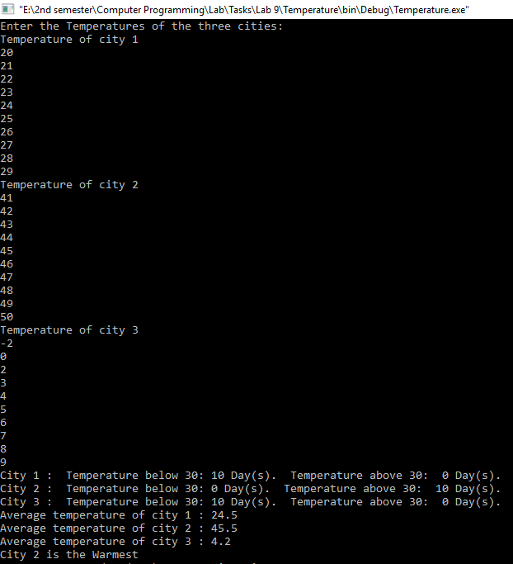

**TASK #2**

Write a program to enter to Cartesian coordinate points and display the distance between them.

**Code:**

#include <iostream>

#include<math.h>

using namespace std;

struct coordinates

{

int x;

int y;

}p1,p2;

void input(coordinates *A)

{

cout<<"X coordinate: ";

cin>>A->x;

cout<<"Y coordinate: ";

cin>>A->y;

}

void distance (coordinates P1,coordinates P2)

{

float exp1=pow(P2.x-P1.x,2);

float exp2=pow(P2.y-P1.y,2);

float exp=pow(exp1+exp2,0.5);

cout<<"Distance between P1 and P2 is: "<<exp;

}

int main()

{

cout<<"Enter the coordinates of P1: \n";

input(&p1);

cout<<"Enter the coordinates of P2: \n";

input(&p2);

distance(p1,p2);

return 0;

}

**Output (Compilation, testing and debugging):**

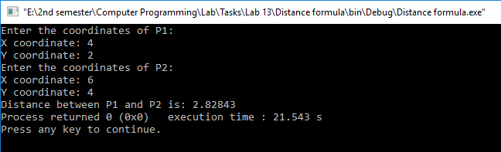

**TASK #3**

UET is maintaining student attendance records by storing rollno, stdname, attendance percentage in 5 different subjects. Write a program to find the average attendance percentage and print the following

a) If attendance percentage >=75 then print student is eligible for writing final exam.

b) If attendance percentage >= 65 and <75 then print student is in condonation list.

c) Otherwise not eligible for writing exams.

**Code:**

#include <iostream>

using namespace std;

void input(int A[3][10]) //Definition of input Function

{

for(int r=0;r<3;r++) //Loop for rows

{

for(int c=0;c<10;c++) //Loop for columns

{

cin>>A[r][c]; //Array Entry

}

}

}

void Average(int A[3][10]) //Definition of Average function

{

float sum[10]={0},Avg[10];

for(int c=0;c<10;c++) //Loop for columns

{

for(int r=0;r<3;r++) //Loop for rows

{

sum[c]+=A[r][c]; //SUM

}

}

for(int i=0;i<10;i++)

{

Avg[i]=sum[i]/3.0; //Average

}

for(int i=0;i<10;i++)

{

if(Avg[i]>=75)

cout<<"Student "<<i+1<<" is eligible for writing final exam.\n";

else if(Avg[i]>=65)

cout<<"Student "<<i+1<<" is in condonation list.\n";

else

cout<<"Student "<<i+1<<" is not eligible for writing final exam.\n";

}

}

int main()

{

int A[3][10]; //Array Declaration

cout<<"Enter the Attendance record of Students: \n"; //Display message

input(A); //Function call

Average(A); //Function call

return 0;

}

**Output (Compilation, testing and debugging):**

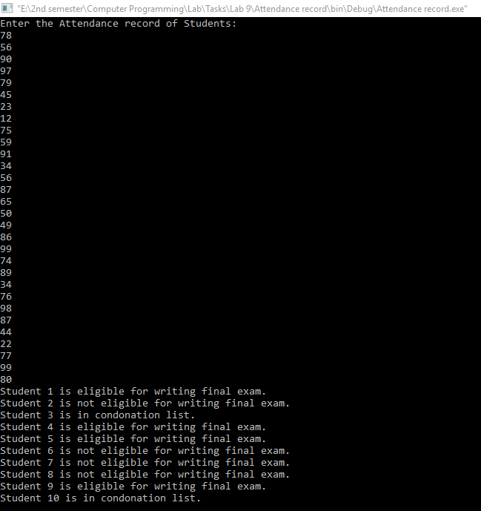

**TASK #4**

Write a structure to store the name, account number and balance of customers (more than 10) and store their information.

i - Write a function to print the names of all the customers having balance less than Rs.200.

ii - Write a function to add Rs.100 in the balance of all the customers having more than Rs.1000 in their balance and then print the incremented value of their balance in ascending order.

**Code:**

#include <iostream>

#include <stdio.h>

using namespace std;

const int SIZE=10;

struct BankAccount

{

char name[30];

int Ac_No;

float balance;

}Account[SIZE];

void input(BankAccount *A)

{

cout<<"Name: ";

cin>>A->name;

cout<<"Account No. : ";

cin>>A->Ac_No;

cout<<"Balance: ";

cin>>A->balance;

}

void BalanceLessThan200 ()

{

for(int i=0;i<SIZE;i++)

{

if(Account[i].balance<200)

{

cout<<Account[i].name<<endl;

}

}

}

void Add100 ()

{

for(int i=0;i<SIZE;i++)

{

if(Account[i].balance>1000)

{

Account[i].balance+=100;

}

}

}

void display()

{

int counter=0;

for (int n=0;;n++)

{

for(int i=0;i<SIZE;i++)

{

if(Account[i].balance==n)

{

cout<<"\nName: "<<Account[i].name;

cout<<"\nAccount No. :"<<Account[i].Ac_No;

cout<<"\nBalance: "<<Account[i].balance;

counter++;

break;

}

}

if(counter==SIZE)

break;

}

}

int main()

{

for(int i=0;i<SIZE;i++)

{

cout<<"Enter the information of customer"<<i+1<<":\n";

input(&Account[i]);

}

cout<<"Customers that have balance less than 200: \n";

BalanceLessThan200();

Add100();

cout<<"Account Balance in Ascending Order: \n";

display();

return 0;

}

**Output (Compilation, testing and debugging):**

